Özel Aksaray OSB Teknokent Koleji Mesleki ve Teknik Anadolu Lisesi

10. Sınıf Birinci Dönem İlk İngilizce Sınavı (2020-2021)

|  |  |
| --- | --- |
| Name:  Surname: | Class:  Student Number: |

Questions

1. Answer these questions. 5x2 points

A. Do you have any brothers or sisters? …..………………………………………….………………………………….

B. How do you come to school? …………………………………………………………………………………..

C. Do you live in a flat? …..……………………………………………………………………………..

D. What’s your favourite pastime? …..……………………………………………………………………………..

E. Do you have your own room? …..……………………………………………………………………………..

2. Fill in the following list. 10x1 point

|  |  |  |  |  |
| --- | --- | --- | --- | --- |
| Geography | English | Maths | History | Chemistry |
| Playing football | Swimming | Watching TV | Shopping | Going to the Cinema |

|  |  |
| --- | --- |
| School Subjects | Free Time Activities |
|  |  |
|  |  |
|  |  |
|  |  |
|  |  |

3. Choose the best answers for the bottom questions . 5x3 points

Jenny is playing the guitar in the ..................... . He’s practicing for the concert.

a. Music Room b. Library c. Gym

The basketball players practice hard in the .................... five times a week.

a. Staff Room b. Computer lab c. Gym

It’s break time so the teachers aren’t in the classrooms. They’re in the ....................

a. Art Room b. Music Room c. Staff Room

The Pupils are having the biology lesson in the …………………………… today because they’re doing an experiment

a. Science Lab b. Computer Lab c. Library

The Pupils are in the …………………………… They are doing research for their geography project on the Internet

a. Staff Room b. Computer Lab c. Art Room

4. Put the following words in the correct column. 10x2 point

|  |  |  |  |  |
| --- | --- | --- | --- | --- |
| Happy | Book | Classroom | Easy | Computer |
| Dangerous | Smart | Telephone | Taxi | Beautiful |

|  |  |
| --- | --- |
| Adjectives | Nouns |
|  |  |
|  |  |
|  |  |
|  |  |
|  |  |

5. Translate into Turkish the following phrases. 5x3 points

In my opinion ……………………………………………………………………………..

Pupils …………………………………………………………..………………..

Knowledge is power …………………………………………………………..………………..

I believe …………………………………………………………..…………………

It seems to me that …………………………………………………………..…………………

6. Read the test below and answer the questions. 5x3 points

Hi I’m Jane. I am 15 years old. I am a student at a high school. I wake up at 6 AM every morning. First, I go jogging then I have a big breakfast.

My lessons begin at 8 AM. We have compulsory subjects until the lunch break at noon. After lunch from 12:30 PM to 3 PM we study are optional subjects.

When I come back home, I usually have some snacks such as tea and a small sandwich. I start my homework at 5:30 PM. After I finished my studies, I watch TV with my family. After dinner I often surf the net for my school projects in the evening. Before I go to bed I listen to some music or read a book. I often sleep at 11 PM.

What time does Jane wake up every morning? ….…………………………………………………………………………

What time does her lessons start? .….…………………………………………………………………………

What does she have after she comes back home? ….…………………………………………………………………………

What does she do after dinner? .……………………………………………………………………………

What time does she sleep? .……………………………………………………………………………

7. Complete the table 10x1 point

|  |  |  |  |  |
| --- | --- | --- | --- | --- |
| Art | Biology | Music | English | Careers Education |
| Physics | Maths | Chemistry | Technology | Design |

|  |  |
| --- | --- |
| **Compulsory School Subjects** | **Optional School Subjects** |
|  |  |
|  |  |
|  |  |
|  |  |
|  |  |

8. Fill in the missing letters and find the free time activities. 5x1 point

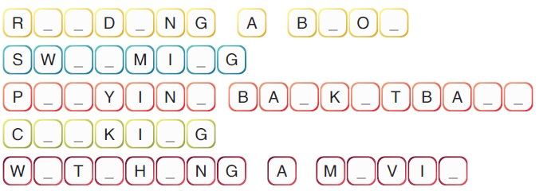

Good Luck!

Uğur Arslan

English Teacher